LSP SENIOR CAPSTONE - DOCUMENTATION

Gabriel Urena

~

Professor Steven Fulakeza

# **Meeting notes:**

[**https://docs.google.com/document/d/19hN9-vH_nqQC32K-40Hd_CGRBZ3CMstdTp9YpHNZvu8/edit?usp=sharing**](https://docs.google.com/document/d/19hN9-vH_nqQC32K-40Hd_CGRBZ3CMstdTp9YpHNZvu8/edit?usp=sharing)

## **Initial wireframe:** [**https://www.figma.com/file/Igz8IZIDd1EgNybj3HYDfL/Grade-Analysis?node-id=2-16&t=4pNpAQ1Bt78QHhWN-0**](https://www.figma.com/file/Igz8IZIDd1EgNybj3HYDfL/Grade-Analysis?node-id=2-16&t=4pNpAQ1Bt78QHhWN-0)

## **Improved Wireframe:** [**https://www.figma.com/file/1tCGfu4jFcmW47Mai6bUxc/Grading---Advising?node-id=0-1&t=5D36YqvF2B2Pjs8J-0**](https://www.figma.com/file/1tCGfu4jFcmW47Mai6bUxc/Grading---Advising?node-id=0-1&t=5D36YqvF2B2Pjs8J-0)

## **Capstone Paper:**

[**https://docs.google.com/document/d/1C311Eis0ofp0nOgA1pEt5rpNbtkbOOuXwsHbzDy6RIU/edit?usp=sharing**](https://docs.google.com/document/d/1C311Eis0ofp0nOgA1pEt5rpNbtkbOOuXwsHbzDy6RIU/edit?usp=sharing)

# Grade Analysis Application Requirements (ROLES)

______________________________________________________________________

**Student**

Login

* Set up advisor meeting
* Upcoming meetings
* Advisor Comments and their info

______________________________________________________________________

**Professor**

Login

* Report and view Incidents
* View Grade analysis
  + Course info *(review with professor)
* Submit ticket for admin

(Professors can be Advisors / and Students)

______________________________________________________________________

**Adviser**

Login

* Meeting Requests
  + Professor’s info, Students info, the date for advising, start time, end time, Reason, Advisor comments
* Submit a ticket for the admin
* (Advisors can be professors)

______________________________________________________________________

**Administrator**

Login

* Ticket system
* Access to everything

____________________________________________________________________________

**Application**

* All CMP students/students taking comp sci classes
  + Emplid, full name, address, sex, ethnicity or race, graduation date, undergraduate or graduate, majors (can be multiple), minor
* Course info
  + Course id, sections, instructors, year
* Grades
  + Student grades
* Feature
  + Incident reports (cheating), Gather student information, instructor, date, description

# User Stories

## **Student**

As a student, I want to log in so that I can make an appointment with an advisor. To do so we would have a login page where you enter the username and password to enter the site.

As a student, I forgot my password and want to get a new one so that I can log in. We would have a forget password button on the login page that would reset your login information.

As a student, I forgot my username and want to get a new one so that I can log in. We would have a forget username button on the login page that would reset your login information.

As a student, I want to schedule an appointment with an advisor so that I can discuss my future. To do so I will have a calendar with available days

As a student, I want to schedule a specific time with an advisor so that I can work around my availability. To do so I will have availability times within the calendar day to show availability.

As a student, I want to confirm my appointment/meeting time so that I do not forget. To do so I will have a reminder at the bottom of the calendar so that I can see my current meetings.

As a student, I want to confirm my appointment on my phone because I don’t have access to a computer. To do so I can look at the calendar on the homepage, it will have a red outline on the date of my meeting with time.

As a student I want to cancel my appointment so that I can make a new one later, to do so I will have a reschedule button to remove any existing meetings or remove them around to another available date.

As a student, I want to see my advisor's information so that I can send them an email. To do so I can go to the navigation bar and click on the advisor, from there I will get their name and email.

As a student I want to see any meeting notes from my previous meetings so that I don’t forget, to do so I need to click on the meeting notes button that reveals a block with meeting dates and notes for each of them right below.

As a student, I want to set up a meeting with my advisor and specific teacher because I want to discuss something from their course. To do so fill out the meeting form and select from my current professors.

As a student, I want to edit my information such as email so that I can organize my notifications better. To do so we will need to have the hamburger menu on the top right of the application and get into settings. Here you can update basic information.

As a student, I want to see the date so I can plan my meeting accordingly. To do so I need to have the date above the calendar and an indication on the calendar itself so it’s not confusing.

As a student, I want to go to the homepage from any window because I want to view the calendar again, to do so there will be a home button at the top left that takes you to the homepage.

## **Faculty**

As a faculty, I want to log in to view any meetings I have. To do so I need to have a login page

As a faculty, I forgot my password and want to get a new one so that I can log in. We would have a forget password button on the login page that would reset your login information.

As a faculty, I forgot my username and want to get a new one so that I can log in. We would have a forget username button on the login page that would reset your login information

As a faculty, I want to see the courses that I teach so that I can schedule a meeting based on that class. To do so I will have a courses tab that brings out a window with my courses.

As a faculty, I want to see upcoming meetings so that I can plan my week accordingly. To do so I can scroll down under the calendar and will see a box with meeting dates and notes for each on underneath.

As a faculty, I want to see upcoming meetings easier on my phone, to do so I will make meetings on the calendar for easy visibility.

As a faculty, I want to see the current date so I know when I am available. To do so I will include the current date and month above the calendar.

As a faculty I want to put my availability on the calendar so that advisors can make meetings properly, to do so I will have an availability form to fill out next to the calendar

As a faculty, I want to set up a meeting with a student and advisor so that I can discuss class, to do so I will have a meeting form that takes the time and information of the meeting participants.

As a faculty, I want to add a note to the meeting when setting up because it will help with organization and letting students and advisors know the purpose of the meetings. To do so I will include a text box for the reason for the meeting.

As a faculty, I want to be able to search for all my students so that I can retrieve proper information. To do so I will have a student search bar that takes in student names or id numbers.

As a faculty I want to see the roster for my course because I want to know who is a member of the class, to do so I will need to be able to click on the course and then have a roster button that has a window with all the current students enrolled.

As a faculty, I want to file an incident report so that I can notify other professors and advisors of issues. To do so I will have a reporting page that lets me fill out a form for the appropriate student.

As a faculty, I want to view the grades of a current student so that I can analyze them. To do so I will have a page that automatically calculates student grades.

As a faculty, I want to see the average grade in a class so that I can view trends. To do so I will take the grades of each student in the class and take the average and plot it on a graph over time.

As a faculty I want to be able to read the numbers instead of viewing the graph because it is faster, to do so I will have the outputs of the graph displayed as text below the charts, and graphs.

As a faculty I want to file a support ticket so that bugs can be fixed, to do so there will be a form that can be filled out when you click the support button at the bottom of the nav bar

As a faculty, I want there to be a navigation bar that holds everything I need so that I can be organized. To do so there will be a navigation bar on the left of the screen for easy access.

As a faculty, I want to go to the homepage from any window because I want to view the calendar again, to do so there will be a home button at the top left that takes you to the homepage.

As a faculty I want to pick different courses when analyzing grades so that I can view trends between classes, to do so I will allow a drop-down menu for courses on the grade analysis page.

## **Advisor**

As an advisor, I want to log in to view any meetings I have. To do so I need to have a login page

As an advisor, I forgot my password and want to get a new one so that I can log in. We would have a forget password button on the login page that would reset your login information.

As an advisor, I forgot my username and want to get a new one so that I can log in. We would have a forget username button on the login page that would reset your login information.

As an advisor, I want to view my upcoming meetings so I can plan my day. To do so I will include a box below the calendar that has upcoming meeting days and times.

As an advisor I want to see the current date so that I can set up meetings, to do so I’ll include the current day and month above the calendar.

As an advisor, I want to set up meetings with professors and students so that I can give my advice. To do so I will have a form to fill out that will art up a meeting time on a date on the calendar.

As an advisor, I want to include a note on the meeting date so that I can inform the participants of anything. To do so I will leave a box in the form just for it.

As an advisor, I want to add a note to an existing meeting to notify the participants of something. To do so once you click on the upcoming meeting you can click edit and you can update any information on the form.

As an advisor, I want to update any information on a meeting. To do so I will include a reschedule button that opens up the meeting form of the selected meeting allowing you to update it.

As an advisor, I want to view any meetings that the student has already done so that I can advise them further, to do so I will have a box above the incident reports, showing the advisement history.

As an advisor, I want to view student info so that I can view any incident reports. To do so click on the student in your meeting and you can see their info (Id, name, address, any incident reports)

As an advisor I want to view a students transcript for advising, to do so I will make it so if you click their name you can access their info page and you can request their transcript from the school

As an advisor I want to search for students so that I can view their info, to do so you can us a search bar to look them up with their id or name.

As an advisor I want to search for professors so that I can view their info, to do so you can us a search bar to look them up with Id or name.

As an advisor, I want to cancel an existing meeting because I no longer need it. To do so I will have a button that lets you select and delete meeting dates on the calendar.

As an advisor I want to file a ticket so that I can get bugs fixed, to do so there will be a ticket form that can be submitted at the bottom left of the nav bar.

As an advisor, I want to have all my options in a single place to help me navigate the website. To do so I will have a nav bar at the left of the screen to keep everything organized.

As an advisor I want to access my homepage from anywhere I am on the application so that I can see the calendar, to do so I will have a home button at the top left of the nav bar.

## **Admin**

As an admin, I want to log in to view any meetings I have. To do so I need to have a login page

As an admin, I forgot my password and want to get a new one so that I can log in. We would have a forget password button on the login page that would reset your login information.

As an admin, I forgot my username and want to get a new one so that I can log in. We would have a forget username button on the login page that would reset your login information.

As an admin, I want to talk to other admins and discuss any questions. To do so there will be a forum included on the homepage.

As an admin, I want to see anything that needs to be taken care of immediately so that I can fix them. To do so I will include an “urgent” tab on the homepage

As an admin I want to see how important one task is to another, to do so I will include a severity level to the left of each task and color-coat them.

As an administrator I want to view my tickets so that I can work on them, to do so I will have a ticket tab that shows all submitted tickets.

As an administrator I want to know who’s on my team, to do so we will have a members tab that shows other administrators and their info.

As an administrator, I want to directly communicate with another admin. To do so there are direct messages that can be accessed through a messages tab.

As an admin, I want to add users so that the application is populated. To do so there will be a add user tab that will let you insert the name, Id, email, and role of the user.

As an admin, I want to remove users so that I can control the population of the application. To do so there will be an option when you search for a particular user to delete them.

As an admin, I want to edit users so that their proper information is present, to do so there will be an edit option when searching for users. Allowing you to change their name, email, Id, and role.

As an admin I want to be able to search for specific users so that I can perform different tasks, to do so I will have a search bar that takes in names and ID numbers.

As an admin, I want a roster of the different professors and advisors

# **Use Case**

Scroll to next page \/

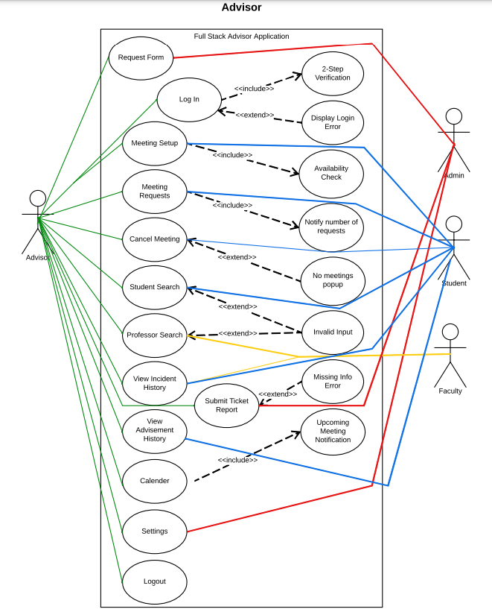

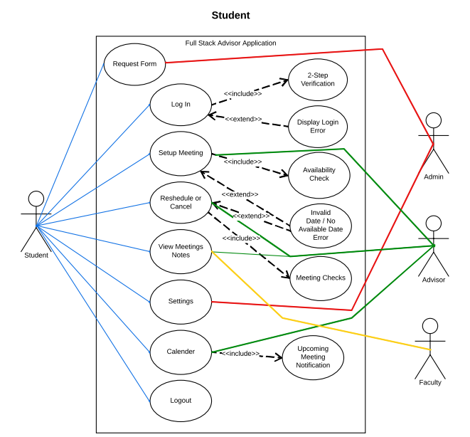

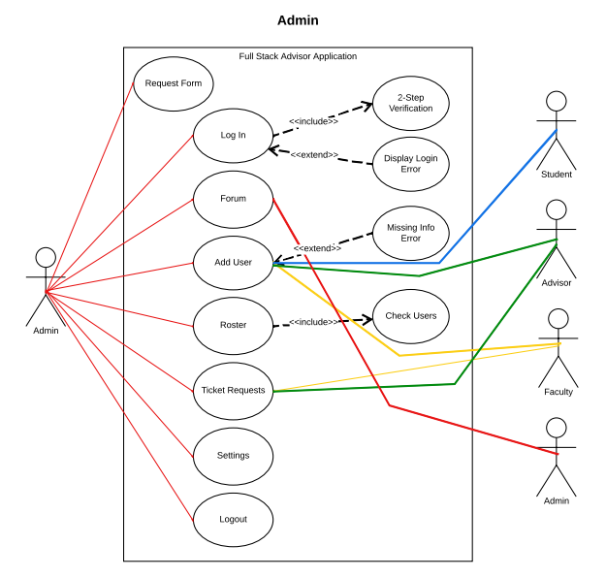

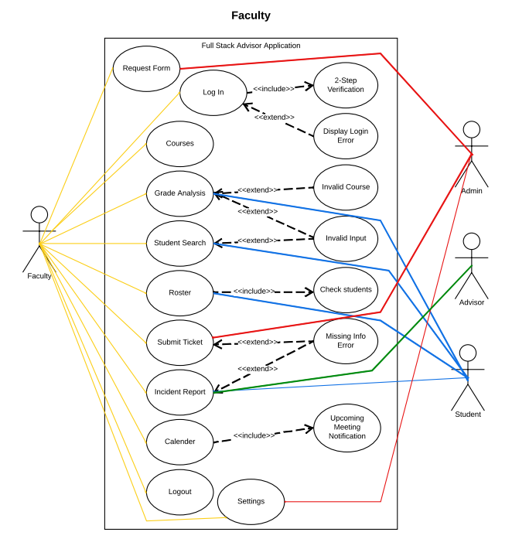

# **Database**

## 

## EER DIAGRAM LINK: <https://lucid.app/lucidchart/b2e7389c-596b-4de1-8804-056b054e081e/edit?beaconFlowId=752B5826004F4A97&invitationId=inv_d0b77d9d-43fa-4a82-bcde-3495b6b7c9a3&page=0_0#>

**Scroll Down for more \/**

## EER DIAGRAM

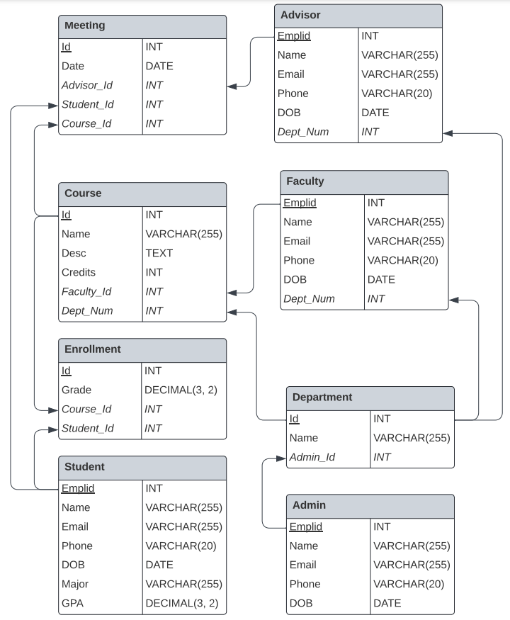

## **ER DIAGRAM**

**Admin**

| Emplid | Name | Email | Phone | DOB |
| --- | --- | --- | --- | --- |

**Advisor**

| Emplid | Name | Email | Phone | DOB | *Dept_Num* |
| --- | --- | --- | --- | --- | --- |

**Course**

| Id | Name | Desc | Credits | *Dept_Num* | *Faculty_Id* |
| --- | --- | --- | --- | --- | --- |

**Department**

| Id | Name |
| --- | --- |

**Enrollment**

| Id | Grade | *Student_Id* | *Course_Id* |
| --- | --- | --- | --- |

**Faculty**

| Emplid | Name | Email | DOB | Phone | *Dept_Num* |
| --- | --- | --- | --- | --- | --- |

**Meeting**

| Id | Date | *Advisor_Id* | *Student_Id* | *Course_Id* |
| --- | --- | --- | --- | --- |

**Student**

| Emplid | Name | Email | DOB | Phone | Major | GPA |
| --- | --- | --- | --- | --- | --- | --- |

# MySQL:

DROP DATABASE IF EXISTS advising;

Create Schema advising;

CREATE TABLE Admin (

emplid int not null,

name varchar(255),

dob date,

email varchar(255),

phone varchar(20),

primary key (emplid)

);

CREATE TABLE Department (

id int not null,

name varchar(255),

admin_id int not null,

primary key (id),

foreign key (admin_id) reference Admin(emplid)

);

CREATE TABLE Advisor (

emplid int not null,

name varchar(255),

dept_num int not null,

dob date,

email varchar(255),

phone varchar(20),

primary key (emplid),

foreign key (dept_num) reference Department(id)

);

CREATE TABLE Faculty (

emplid int not null,

name varchar(255),

dept_num int not null,

dob date,

email varchar(255),

phone varchar(20),

primary key (emplid),

foreign key (dept_num) reference Department(id)

);

CREATE TABLE Student (

emplid int not null,

name varchar(255),

major varchar(255),

dob date,

gpa decimal(3, 2),

email varchar(255),

phone varchar(20),

primary key (emplid)

);

CREATE TABLE Course (

id int not null,

name varchar(255),

desc text,

dept_num int not null,

credits int,

faculty_id int not null,

primary key (id),

foreign key (dept_num) reference Department(id),

foreign key (faculty_id) reference Faculty(emplid)

);

CREATE TABLE Enrollment (

id int not null,

student_Id int not null,

course_Id int not null,

grade decimal(3, 2),

primary key (id),

foreign key (student_id) reference Student(emplid),

foreign key (course_id) reference Course(id)

);

CREATE TABLE Meeting (

id int not null,

advisor_Id int not null,

student_Id int not null,

course_Id int not null,

date date,

primary key (id),

foreign key (advisor_Id) reference Advisor(emplid),

foreign key (student_Id) reference Student(emplid),

foreign key (course_Id) reference Course(emplid)

);